**Design Document**

*Deployment Plan*

The application can be planned to be deployed as a background service. There is a settings files, this can be configured to the location where the order files will be deployed. Also can be extended to include more configurations like URL etc.

*High-Level Design Diagram*

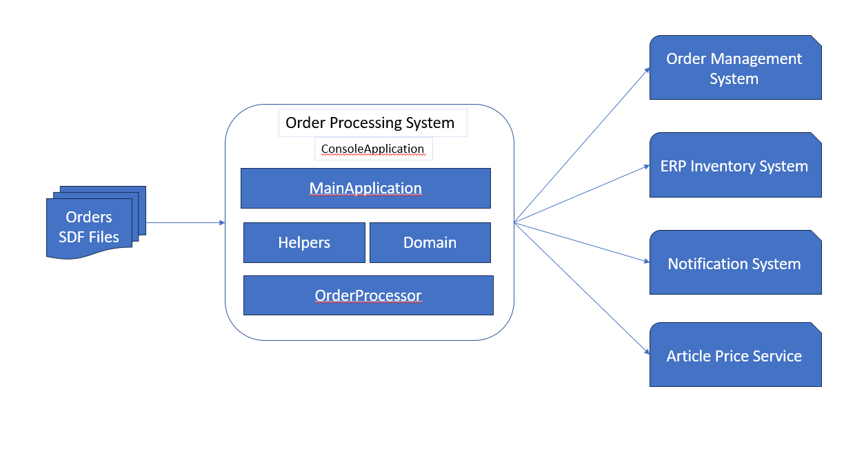

Figure : High level Component Diagram

*Class Diagrams*

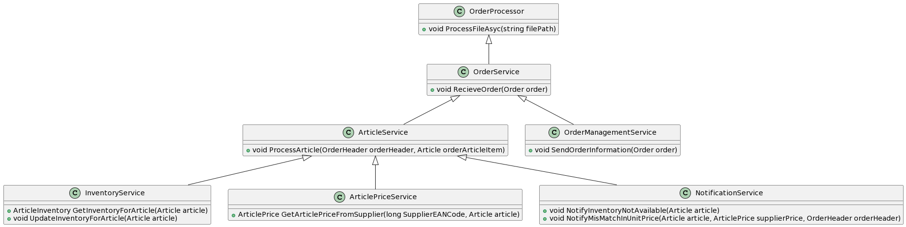

Figure : Domain Class Diagram

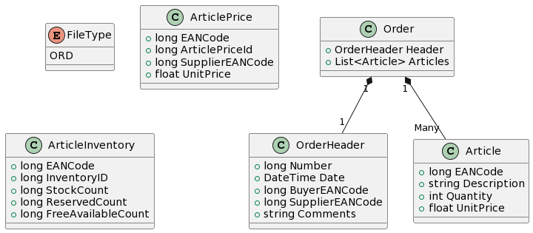

Figure : Domain Models

*Assumptions*

1. Notification will be handled by the backend servers and API will be provided for it
2. ERP based Inventory Service will provided for later integration
3. Order Management Systems API will be provided for later integrations.

*What more could be done or done differently*

1. Validations will be separated and made more separate
2. Add more Unit tests
3. Bring check-point based processing of order, to resume in the event of failure or abnormal termination.
4. Parallel asynchronous processing of orders right after fetching from the flat file.